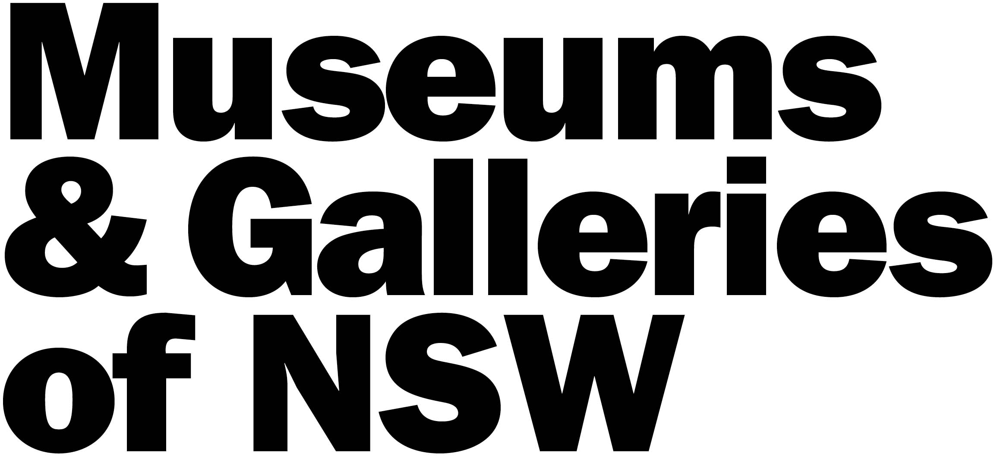

Schedule A – Supporters Acknowledgements

As supporters of the DEG program, Museums & Galleries of NSW, the Sir William Dobell Art Foundation and Create NSW must be acknowledged with logos on all printed and digital material related to the project including (but not limited to):
- Signage accompanying the project
- Invitations – both electronic and hard copy
- Generic press releases
- Local press releases written by the gallery
- Education kits/ marketing materials and catalogues produced
- Online promotion and website
- Social media promotions
- Paid advertising by the gallery

Tagline
The following new tagline must be included on ALL promotion and educational material where able:
This exhibition is supported by the Dobell Exhibition Grant, funded by the Sir William Dobell Art Foundation and managed by Museums & Galleries of NSW.

Logos
The following logos can be downloaded from the M&G NSW website at:
https://mgnsw.org.au/sector/funding/grants-we-administer/gallery-grants/dobell-exhibition-grant/
These logos are to be displayed in the order shown below. Should you need another electronic version please contact M&G NSW on the below contacts.

- Museums & Galleries of NSW – to be included on all promotional material

- Sir William Dobell Art Foundation – to be included on all promotional material

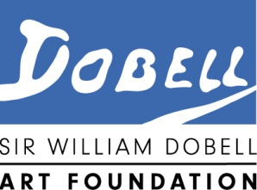

- Create NSW – to be included on all promotional material

This project is supported by the NSW Government through Create NSW

Approval
All printed and electronic material developed by the gallery must be submitted for approval to M&G NSW at least ONE WEEK prior to print/publication date.

Please submit material for approval to:
Susan Wacher, Funding & Programs Manager, T: 0411 530 006 E: susanw@mgnsw.org.au

